IEICE Word Template (Title)

－The Format of Technical Report (Subtitle)－

Hanako DENSHI† Taro JOUHO‡ and Jiro TSUSHIN‡

†Faculty of Engineering, First University 1-2-3 Yamada, Minato-ku, Tokyo, 105-0123 Japan
‡R&D Division, Osaka Corporation 4-5-6 Kawada, Suita-shi, Osaka, 565-0456 Japan

E-mail: †hanako@denshi.ac.jp, ‡{taro, jiro}@jouhou.co.jp
Abstract IEICE (The Institute of Electronics, Information and Communication Engineers) provides a word template file for the Technical Report of IEICE.
Keywords Windows，Word，Technical Report，Template

- Introduction
  - General Information
ICSANE 2019, The 14th International Conference on Space, Aeronautical and Navigational Electronics 2019 will provide an opportunity for system engineers and researchers to discuss new and viable technical topics of electronics system in spacecraft, aircraft, ships and ground facilities. Topic areas include but are not limited to:
(1) Satellite and space-station systems
(2) Remote sensing & scientific observation technology
(3) Radar systems and applications
(4) Navigational and communication systems
(5) Inverse scattering
etc.
All papers should be submitted electronically to Technical Program Committee of SANE (http://www.ieice.org/cs/sane/eng) with the title of the paper (six A4 pages max.), the author’s name(s), affiliation, and contact information by following dates. The contact information should include postal address, telephone/ facsimile number and e-mail address. Presenters of ICSANE2019 must pay the submission fee of JPY 3240 at the payment page of submission web system, that will be announced in a registration mail, and will download the electric proceedings. Authors of the presented papers are recommended and invited to submit an extended paper for consideration of publication in IEICE Transactions on Communications.

- Number of Page
The number of pages is typically 4, maximum 6.

- Format, File Type and Language
IEICE Technical Report Format (2-column) (This file), PDF and English.

- Tables, Figures and Equations
  - Tables and Figures
To insert “Tables” or “Figures”, please paste the data as stated below. All tables and figures must be given sequential numbers (1, 2, 3, etc.) and have a caption placed below the figure or above the table.

Table1 1 Margin specifications.
Margin | A4 Paper
Left | 15 mm
Right | 15 mm

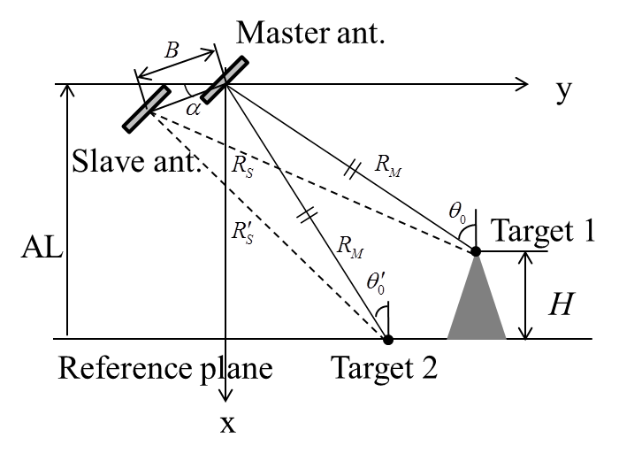
Fig. 1 Geometry of interferometry.

  - Equations
If a displayed equation needs a number, place it flush with the right margin of the column (e.g., see Eq. 1).
$\begin{aligned}y_{i}(N)=\sum_{n=0}^{m−1}{w_{n}(N)b_{n}(N)} \\ \sum_{n=0}^{m−1}{\overline{b_{n}^{}(N)r_{i}(N)}}⋅b_{n}(N)\end{aligned}$ (1)

- Important Dates
Deadline for Abstract Submission: Mid-August, 2019
Deadline for Camera-ready Paper: Early-October, 2019

- Contact person
Prof. Toshifumi Moriyama (Nagasaki Univ.)
E-mail: t-moriya@nagasaki-u.ac.jp

References
- W. Rice, A. C. Wine, and B. D. Grain, diffusion of impurities during epitaxy, Proc. IEEE, vol.52, no.3, pp.284-290, March 1964.
- H. Tong, Nonlinear Time Series: A Dynamical System Approach, J. B. Elsner, ed., Oxford University Press, Oxford, 1990.
- H. K. Hartline, A. B. Smith, and F. Ratlliff, Inhibitoryinteraction in the retina, in Handbook of Sensory Physiology, ed. M. G. F. Fuortes, pp.381-390, Springer-Verlag, Berlin.
- Y. Yamamoto, S. Machida, and K. Igeta, “Micro-cavity semiconductors with enhanced spontaneous emission, ” Proc. 16th European Conf. on Opt. Commun., no.MoF4.6, pp.3-13, Amsterdam, The Netherlands, Sept. 1990.

