IEEE EMCS One-Page Abstract-Reviewed Paper
First A. Author1¹, Second B. Author2¹, and Third C. Author3²
¹Department of Electronic Engineering, ABC University, City, State, Country, emails: author1@abc.edu, author2@abc.edu
²EMC Lab, Company, City, State, Country, email: author3@company.com

Abstract—The EMC Society (EMCS) one-page Abstract-Reviewed paper should contain an abstract, introduction, key methodology or techniques developed or used, key findings/results, discussion, and a few key references. The Abstract should be between 30-120 words. Abstract should not contain mathematical expressions or tables. Any acronyms used in the title must be spelled out in the abstract unless they are well known to IEEE publication readers like IEEE and EMC. All English in paper is font Times New Roman. Title font size is 24pt, abstract is bold 9pt, text is 10pt, and figure heading is 8pt. Title length is limited to no more than two lines.

INTRODUCTION
Provide a sentence or two that describes the background technology that forms the basis of your paper. Specify the main objective(s) of the study presented in this Abstract. State the novelty of your work as compared to the published results or what value your work is to the EMC/SIPI topics.
Use at least one reference [1]. Do not use the word “reference” or “Ref.” except at the beginning of the sentence: “Reference [1] shows…” Define abbreviations and acronyms the first time they are used in the text, even after they have already been defined in the abstract. Abbreviations that incorporate periods should not have spaces: write “C.N.R.S.,” not “C. N. R. S.” Do not use abbreviations in the title unless they are unavoidable (for example, “IEEE” in the title of this article).
Use one space after periods and colons. Hyphenate complex modifiers: “zero-field magnetization.” Avoid contractions, e.g., “don’t.” (write “do not”). The serial comma is preferred: “A, B, and C” instead of “A, B and C.” Remember to check spelling. Any additional information not provided in this one-page template can be found in IEEE “Transactions template and instructions on how to create your article”.
One-page Abstract papers will be included in the EMC Symposium Proceedings but will not be published in IEEE Xplore®.

METHODOLOGY
In this Section, briefly describe the methodology of your study. You may add the needed references [2], [3], or [2]-[5]. Footnotes are not recommended. Number equations consecutively with equation numbers in parentheses flush with the right margin, as in (1). Use either the Microsoft Equation Editor, or the MathType add-on (http://www.mathtype.com) to create the equations, e.g.,
(1)
where comma is used after the equation if variables are specified after this equation. Treat equations as parts of sentences with all the needed punctuation before and after the equations. Inserting a table with two unequal columns, one row, and no borders and shading for an equation is recommended. All variables in formulas must be identified (except for mathematical constants like e or π).
SI units are strongly encouraged, but CGS can be also used, if the proper conversion is shown. English units may be used as secondary units (in parentheses).
There are some common mistakes that must be avoided, see Write Your Paper and guidelines in the templates. A general IEEE style guide is available at www.ieee.org/authortools. Figures should be mentioned in the text are referred, e.g., as Fig. 1, exactly as in the caption to the figure.
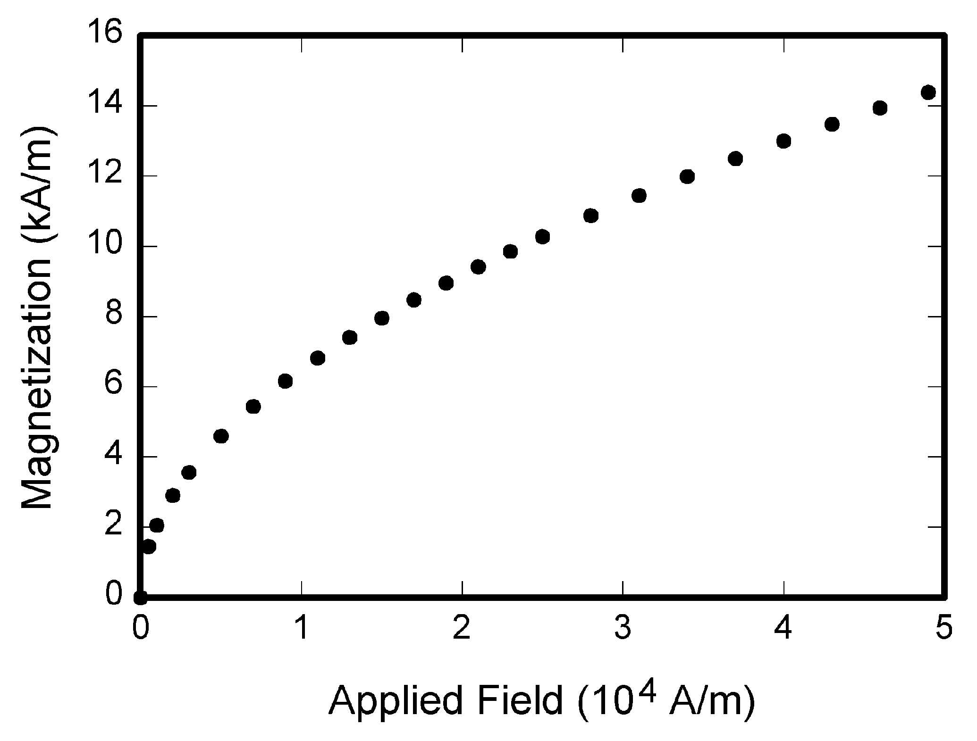
Fig. 1. Magnetization as a function of applied field. Note that “Fig.” is abbreviated. There is a period after the figure number, followed by two spaces. Fonts should be readable, lines easy to distinct.

RESULTS AND CONCLUSIONS
Provide brief description of results of this work. The results can be illustrated by figures, e.g., as is shown in Fig. 1. Figures can be colored, but a reader should be able to distinct lines when printed in black-and-white. Use different line styles, line thicknesses, and colors, and the proper labeling of lines to make your figures clear and readable. If you use tables, they should be numbered with Roman numerals, e.g., as Table I.

- Table Type Styles
Table Head | Table Column Head
 | Table column subhead | Subhead | Subhead
# | More table ccontents | aaa | bbb

In the References section, use the standard reference style provided by the IEEE “Transactions template and instructions on how to create your article”.

REFERENCES
[1] W.-K. Chen, Linear Networks and Systems. Belmont, CA, USA: Wadsworth, 1993, pp. 123–135.
[2] J.S. Turner, “New directions in communications,” IEEE J. Sel. Areas Commun., vol. 13, no. 1, pp. 11-23, Jan. 1995.
[3] Transmission Systems for Communications, 3rd ed., Western Electric Co., Winston-Salem, NC, USA, 1985, pp. 44–60.
[4] D.B. Payne and J.R. Stern, “Wavelength-switched pas- sively coupled single-mode optical network,” in Proc. IOOC-ECOC, Boston, MA, USA, 1985, pp. 585–590.
[5] J.O. Williams, “Narrow-band analyzer,” Ph.D. dissertation, Dept. Elect. Eng., Harvard Univ., Cambridge, MA, USA, 1993.

