Instruction for Camera-Ready Extended Abstract for AWAD 2023
Taiji Noda¹, Tomoyuki Suwa², Woo Young Choi³, and Shun-ichiro Ohmi⁴
¹Panasonic, ²Tohoku Univ., ³Seoul National Univ., ⁴Tokyo Tech,
J2-72, 4259 Nagatsuta, Midori-ku, Yokohama 226-8502, Japan
Email: ohmi@ee.e.titech.ac.jp / Phone: +81-45-924-5481

1. Introduction
This set of formatting instructions pertains to the preparation of a camera-ready paper for the AWAD2023. The extended abstract should clearly and concisely state the originality and specific results of the work.

2. Experimental Procedure
The authors are encouraged to submit a 2-page maximum camera-ready abstract written in English in A4-size. Set the top, bottom, and left/right margins to 28 mm, 24 mm, and 15 mm, respectively. The first page should begin with the title, author(s), affiliation(s), contact author’s address and e-mail address. The title should be written in boldface and title case (i.e. all words except articles, prepositions, and conjunctions are capitalized). The main text must be in single-column format with single spacing and full justification. Section headings should be given in boldface.
Do not use fonts smaller than the fonts specified in Table I. As an aid to gauging font size, 1 point is about 0.35 mm. Use a proportional, serif font such as Times or Dutch Roman.
Photographs should have high contrast in black and white. Figure captions should be placed just below their corresponding figures, while table captions should be placed above their corresponding tables
References should be given in a numerical list at the end of the manuscript and cited in the main text by enclosing a reference number in square brackets [1].

3. Results and Discussion
Authors are requested to submit the manuscript in both docx and pdf file format. (The AWAD paper submission system will require both Word docx and pdf files to be uploaded. Otherwise, it will generate the error message.) Please use standard English fonts such as Times New Roman and Arial, and embed all fonts to ensure that the printed document appears as intended. The manuscript should be proofread carefully beforehand in terms of spelling, grammar, and figure image quality.

4. Conclusions
This is a template for the camera-ready paper of AWAD2023

Acknowledgements
This work was supported by Grant Number xxx, National Science Foundation. (example).

References
- S. Kasai et al., Appl. Phys. Express 11, pp. 037301.1-4 (2018).
- S. Ohmi et al., Ext. Abst. of AWAD2019, pp. 146-147 (2019).
- T. Suwa et al., Jpn. J. Appl. Phys. 52, pp. 031302.1-14 (2013).

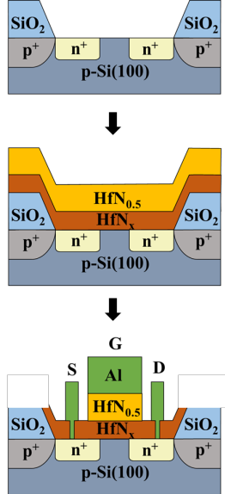

Fig. 1 This is a sample figure. Captions exceeding one line are arranged like this [1].
Table I Font sizes for camera-ready abstract.

Font Size | Bold | Text
11 |  | Main text, authors’ affiliations, figure captions, table, table captions, references, acknowledgements
11 | Yes | Headings, i.e. section title
12 |  | Authors’ names
14 | Yes | Paper title

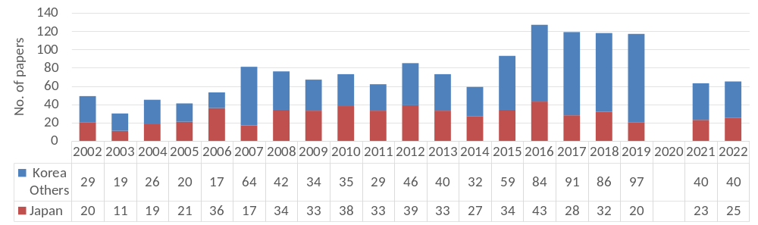

Fig. 2 This is a sample figure.

