TJMW2026 Word Template (Title)

- The Format of Non-Published Paper (Subtitle) -

Hanako DENSHI† Taro JOUHO‡ and Jiro TSUSHIN‡

†Faculty of Engineering, First University 1-2-3 Yamada, Minato-ku, Tokyo, 105-0123 Japan
‡R&D Division, Osaka Corporation 4-5-6 Kawada, Suita-shi, Osaka, 565-0456 Japan

E-mail: †hanako@denshi.ac.jp, ‡{taro, jiro}@jouhou.co.jp
Abstract TJMW2026 (2026 Thailand-Japan MicroWave) provides a word template file for the non-published papers (Abstract is recommended around 100 words).
Keyword Windows, Word, TJMW, Template

- Main Text
  - Text Formatting
Authors are invited to submit technical papers describing original work and/or advanced practices on Radio-Frequency, microwave, millimeter-wave, and terahertz (THz) theory and techniques. Papers should be 1 page (or more) abstract for non-published papers (without peer review), and should not exceed three megabyte in file size. The first page contains paper title, author list, affiliation(s), 100-word-abstract, and keywords.
Each major section begins with a Heading in 10 point Times (New Roman) font and numbered using Arabic numerals, followed by a period, a single space, and the title using an initial capital letter for each word. The remaining letters are in small capitals.
For the body of your paper, use 10-point Times font and set your line spacing at "exactly 12 points" with 0 points before and after. Indent each paragraph by 0.125 inches.

  - Equations
Equations should be centered in the column and numbered sequentially. Place the equation number to the right of the equation within a parenthesis, with right justification within its column. An example would be
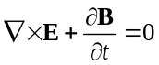. (1)
Note that a period is used to properly punctuate the previous sentence. It is placed at the end of the equation. Make sure that any subscripts in your equations are legible and are not too small to read! When referring to an equation, use the number within parenthesis. For example, you would usually refer to the second equation as (2) rather than equation (2). If possible, use the Symbol font for all special characters, or better yet, use Equation Editor™ or MathType™. The paragraph spacing will need to be set to "single" rather than "exactly 12 point" so that the height will autoscale to fit the equation.

  - Figures
Figures should utilize as much of the column width as possible in order to maximize legibility. Do not use any font smaller than 8-point! It must be legible. When referring to a figure, use the abbreviation Fig. followed by its number. Place figure captions directly below each figure.
Within Microsoft Word there are several options for placing figures within your paper. Often the easiest is to insert them between existing paragraphs allowing the figures to remain in that relative position. The paragraph description where the figure is inserted must be set to "single" spacing rather than "exactly 12 points" in order to allow the line to autoscale in height to display the entire figure. Some disadvantages of this approach are that you don't have total flexibility in placing figures, and that the figures will move as text is inserted or deleted in any part of the document before the figure. If you elect to use this approach, it is recommended that you nearly complete the editing of your text before inserting any figures. Remember to allow room for them, however. Then begin inserting figures starting from the beginning of your document. Do not lump all figures at the end of the paper!
If you have difficulties with the titles on your figures, you can always elect to add in the titles as separate text boxes, rather than importing the titles with the graph. This is sometimes helpful in getting a lengthy vertically-oriented title to display correctly.
Notice that prior to the graph, a single 12-point line is used to separate the preceding text from the graph. The equivalent of a blank line should exist between the bottom of the graph (the x-axis caption) and the figure caption. (In this particular case, there was no need to add a blank line between the x-axis label and the figure caption, because there was already adequate spacing provided by the image border.) After the figure caption, there should be a single 12-point blank line before the text resumes.
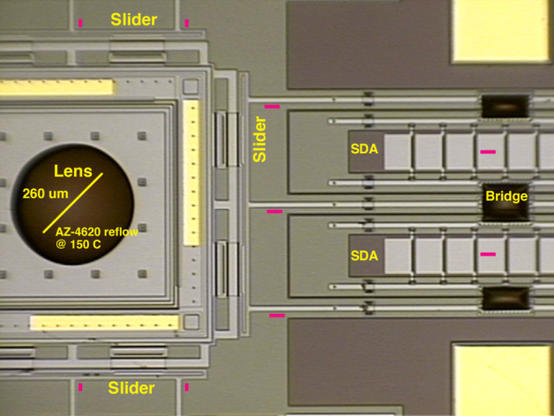
Fig.1. Include all graphics in the manuscript file. Do not submit figures in separate files.

More flexibility is obtained in inserting figures if you can place them exactly where you would like them to be on a page. This can be accomplished by inserting the figure, selecting the figure, and then choosing "Format Picture...". Various settings allow you to place the figure at an absolute position on a page; specify if the text is supposed to flow around the figure or if the figure should move with the text, etc. If you elect to let the text flow around the figure, then remember that you will have to insert a separate text box for the caption, otherwise the figure caption is likely to become separated from the figure.
If you decide to use color traces in your graphical data, be absolutely certain that there is no ambiguity about your graphical information when printed on a B&W printer.

References
- B. Author1, C. D. Author2, and E. F. Author3, “Title of journal paper with a comma inside the quotation marks like this,” Journal Title in Italic vol. 12, no. 3, pp. 456-789, month, year.
- B. Chapter-Writer, “Title of quoted chapter” in Book Title in Italic without Quotation Marks, ed. C. D. Editor, pp. 123-456, Publisher Name, City, year.
- B. Book-Author, Book Title in Italic without Quotation Marks, Publisher Name, City, year.
- B. Author1, C. D. Author2, and E. F. Author3, “Title of paper in proceeding,” Proc. 12th Conf. Name, City, Country, paper ID, pp. 123-456, month, year.

