Transportation
- There are three choices from Pudong Airport (PVG) to Fudan University
- Take taxi (about 50 minutes, about 200 RMB).
- Take Maglev Speed Train to Long Yang Road Station (40 RMB), then take taxi (about 60 RMB).
- Take Airport Bus Line 4, get off at "Wu Jiao Chang" (the second stop) (20 RMB). Then walk about 10 minutes.
- There are two choices from Hongqiao Airport (SHA) to Fudan University
- Take taxi (about 90 RMB).
- Take Bus No. 941 to South Square of Shanghai Railway Station, then take 5-minute-walk to North Square. Take Bus No. 942 to Fudan University.
- From Shanghai Railway Station to Fudan University
- Exit at the South Square of Shanghai Railway Station, then take 5-minute-walk to North Square. Take Bus No. 942 to Fudan University.

- Or take taxi(about 35 RMB).
- From Shanghai South Railway Station to Fudan University
- Take Subway Line 3 to Da Bai Shu Station, then take taxi (about 12 RMB) or take Bus No. 133, or 866 to Fudan Universtiy.

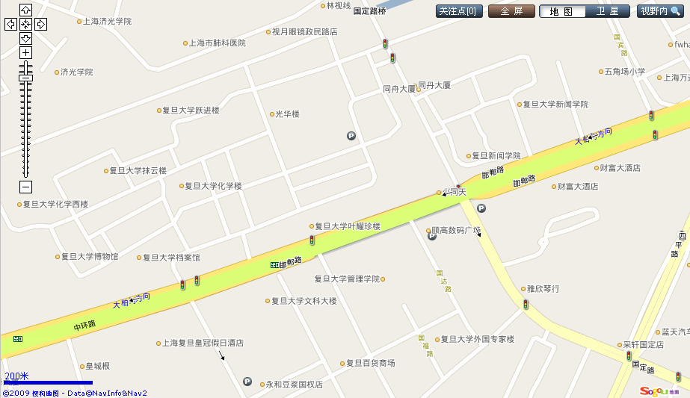
Five-star hotel
3-star hotel (Qing-Yun)
卿云宾馆
Conference venue
(Guang-Hua tower)

Registration Room (East building1101)
Conference Room (E103)
Airport Shuttle Bus
No.4 Stop (WuJiaoChang)
Bus Stop (No. 133, 866, 942, etc)

